**NAAN MUDALVAN ASSIGNMENT**

**NAME:** MEGHA A V

**DEPARTMENT**: BE BIOMEDICAL ENGINEERING

**COLLEGE**: 8151 DHANALAKSHMI SRINIVASAN INSTITUTE OF TECHNOLOGY

**NAANMUDHALVAN COURSE**: DIGITAL MARKETING

**NM ID**: 1E5AE0EB1BB255D8F79442340C50C6B5

ASSIGNMENT 1:

Create a blog or website using Blogspot and word press. Customize the theme design and post new article with 500 words.

URL: https://wordpress.com/post/meadowhomedecors.wordpress.com/9

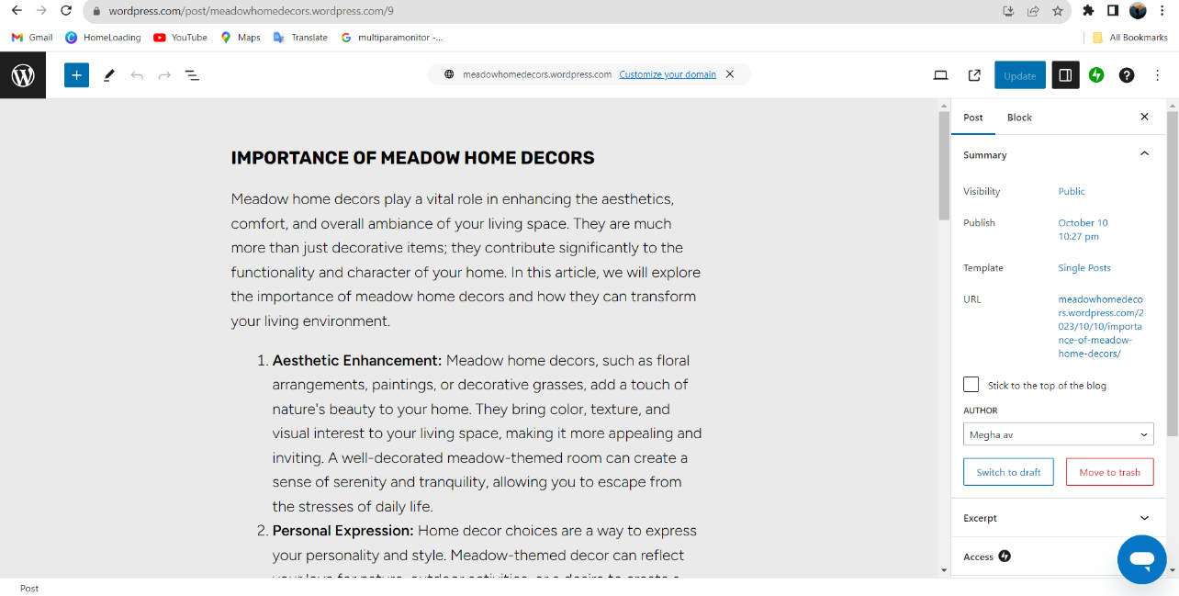

ASSIGNMENT 2:

Create a new Facebook business page and post one social media poster for your brand.

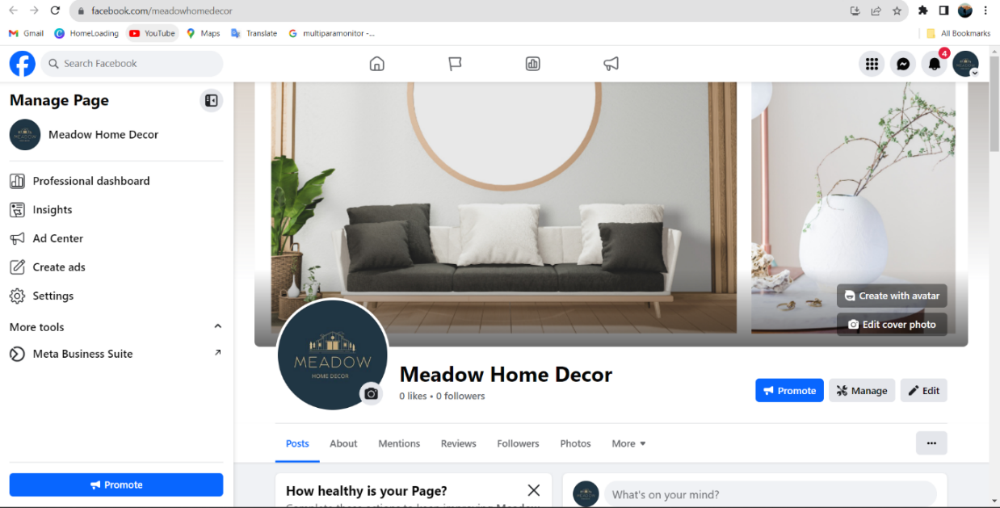URL: <https://www.facebook.com/meadowhomedecor>

ASSIGNMENT 3:

Create and design a advertisement poster using Canva.

URL: https://www.facebook.com/photo?fbid=122110906100007769&set=a.122110906874007769

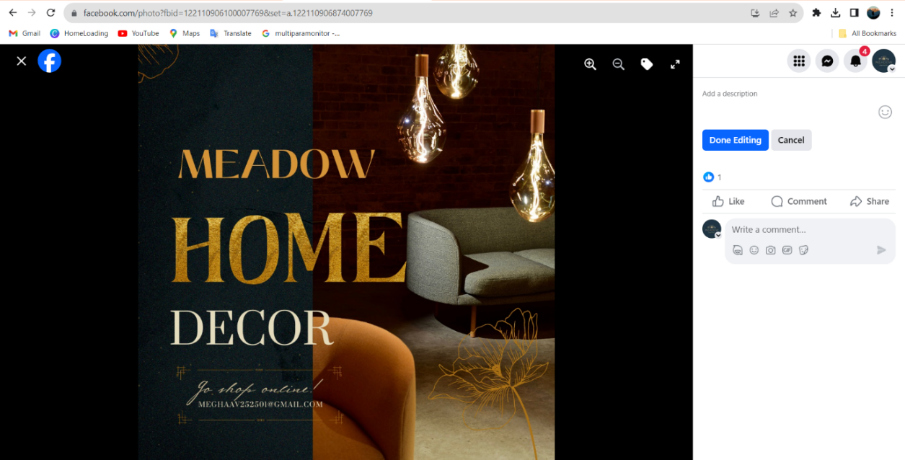

ASSIGNMENT 4:

Create an E mail newsletter design using Mailchimp or Canva tool.

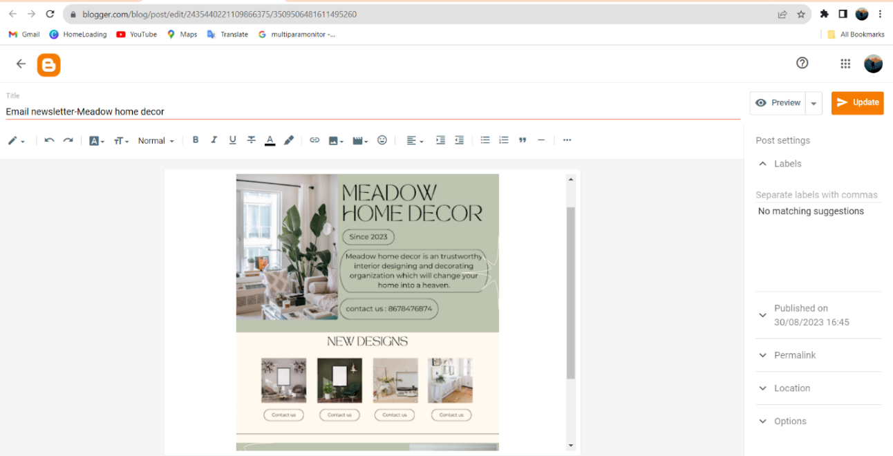URL: <https://www.blogger.com/blog/post/edit/2435440221109866375/3509506481611495260>